Assignment No.2

File Handling Commands in UNIX

In UNIX there are three basic types of files,

- ORDINARY FILES − An ordinary file is a file on the system that contains data, text, or program instructions. In this tutorial, you look at working with ordinary files.

- DIRECTORIES − Directories store both special and ordinary files. For users familiar with Windows or Mac OS, UNIX directories are equivalent to folders.

- SPECIAL (DEVICE) FILES − Some special files provide access to hardware such as hard drives, CD-ROM drives, modems, and Ethernet adapters. Other special files are similar to aliases or shortcuts and enable you to access a single file using different names.
THE PARENT-CHILD RELATIONSHIP:

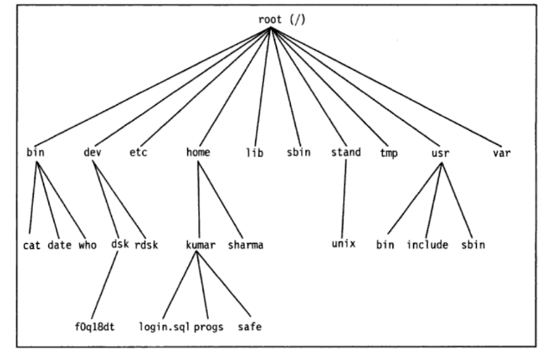
FIGURE 4.1 UNIX file system

- pwd
Use to know current working directory.

- cd
Use to change the current directory

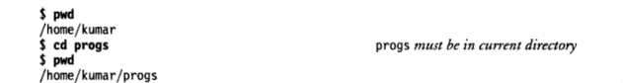

To Move Upward Directory, use cd .. or cd\
- mkdir
Use to create directories.

- rmdir
Use to remove directories

- ls
Give a list of all filenames in the current directory

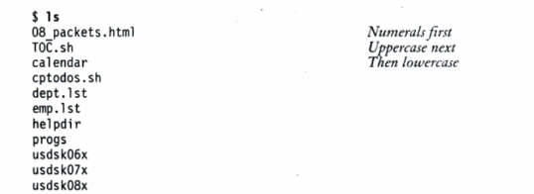

Options withls
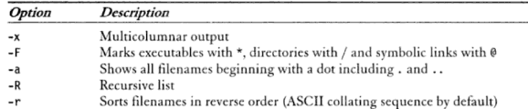

- cat
Used to create a file and also used to open file content

Example:
- $cat>file1 to create file1
- $cat file1 to view content of file1

- cp
Used to copying files

Example:
cp chap01 unit1
cp chap01 progs/unit1

cp chap01 chap02 chap03 progs multiple file copuing into progs directory

cp chap* progs copies all file beginning with chap

cp –i chap01 unit1 interactive copying

cp –R progs newprogs directory copying with files

- rm
Used to delete one or more files.

Example:
rm chap01

rm chap01 chap02 chap03 multiple file deletion

rm progs/chap01 progs/chap02

rm * remove all files

- mv
it renames or moves files.

Example:
mv chap01 man01

mv chap01 chap02 chap03 progs multiple files moved to progs directory

mv progs newprogs rename a directory

- file
Used to determine the type of file
Syntax:
$file [filename]

Example:
- wc
Counts lines, words and characters

Example:


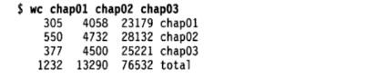
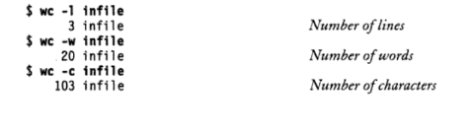

- od
Displays octal data

Example:
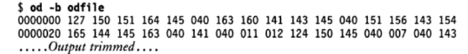

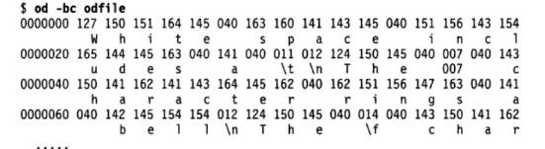

- cmp
Used to compare to files and gives position of first mismatch as a result

Example:

- comm
Find common between two files.

Example:
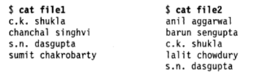
$commfile1 file2

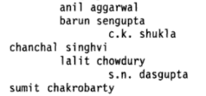

- diff
Used to display file differences and also tells which lines in one file have to be changed to make the two files identical

Example:

